REST vs GraphQL
1. What is REST?
REST (Representational State Transfer) is an architectural style used to build web APIs.
In REST, everything in your application is treated as a Resource (e.g., a book, an author, a user, an order). Each resource gets its own unique web address, called a URL or Endpoint.
To interact with these resources, you use standard HTTP Methods (verbs) as actions. This concept is called CRUD (Create, Read, Update, Delete).
Our Bookstore Running Example:
If you want to manage books in your store, a REST API sets up clean, predictable URLs coupled with HTTP verbs:
- POST /api/books Create a new book in the store.
- GET /api/books Read a list of all books.
- GET /api/books/42 Read the details of the specific book with ID 42.
- PUT /api/books/42 Update all details of book 42 (e.g., change the price and title).
- DELETE /api/books/42 Delete book 42 from the store.
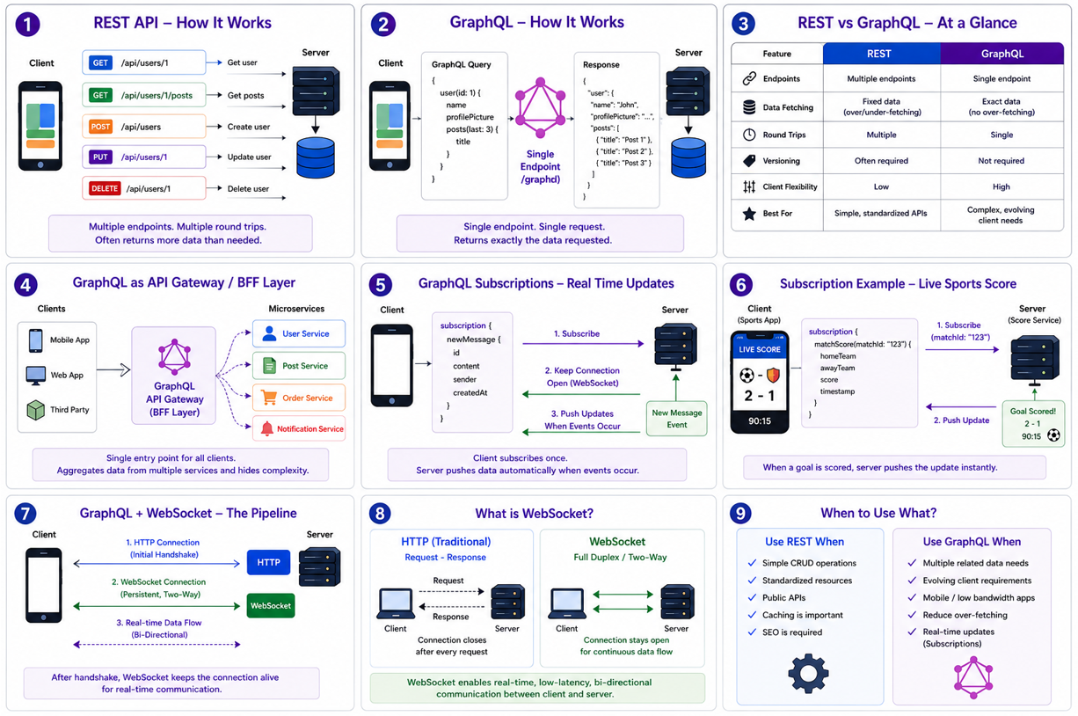

2. What are HTTP Status Codes?
When a client (like your browser or mobile app) talks to a REST API, the server must reply using a standardized numeric code. Think of HTTP codes like universal hand signals that tell the client exactly what happened to their request.
They are broken into distinct mathematical ranges:
🟢 2xx Success (Everything went smoothly)
- 200 OK: Your request was successful, and here is your data. (e.g., You fetched the details for Harry Potter).
- 201 Created: Success! A new resource was created. (e.g., You successfully added a new book to the database).
🔵 3xx Redirection (You need to go somewhere else)
- 304 Not Modified: The data hasn't changed since you last checked. Use your cached copy to save internet data.

🟡 4xx Client Error (The mistake is on the client's side)
- 400 Bad Request: The server doesn't understand what you want because your request data is malformed.
- 401 Unauthorized: You aren't logged in. You need to provide a password/token to see this data.
- 403 Forbidden: You are logged in, but you don't have permission. (e.g., A regular customer trying to hit DELETE /api/books/42—only admins can do that).
- 404 Not Found: The resource you are looking for does not exist. (e.g., Searching for a book with ID 999999).
🔴 5xx Server Error (The mistake is on the server's side)
- 500 Internal Server Error: The server crashed, threw a code exception, or the database died. It's the developer's fault, not yours.
- 503 Service Unavailable: The server is temporarily overloaded or down for maintenance.

3. Benefits of REST
Why has the entire internet relied on REST for over two decades?
- Incredibly Simple and Standardized: It leverages the existing rules of the internet (HTTP). Developers don't need to learn a custom protocol; they already know how GET, POST, and URLs work.
- Highly Cacheable (Performance): Because GET /api/books/42 is a static URL, web browsers and Content Delivery Networks (CDNs) can save a copy of the response locally. If 1,000 users look at that book, the server only has to do the heavy lifting once.
- Separation of Concerns: The backend doesn't care how the frontend looks. The same REST API can serve a mobile iOS app, an Android app, a React website, or a smart watch simultaneously.
- Statelessness: The server doesn't remember previous requests. Each request contains all the information needed to fulfill it. This makes it incredibly easy to scale out by simply adding more servers.

4. Drawbacks of REST
Despite its dominance, REST faces significant challenges in modern, data-heavy applications:
1. Over-fetching (Wasted Bandwidth)
The server dictates the exact data structure. If you only want to display a list of book titles on a mobile homepage, calling GET /api/books will still force the mobile phone to download the full summary, the publisher info, the author's biography, and the 500-character image URLs. This wastes cellular data.
2. Under-fetching (The Multi-Trip Problem)
If a user clicks on an order confirmation screen, the frontend might need to display the Order info, the User's profile, and the Book details. In traditional REST, you have to make three separate network trips:
- GET /api/orders/5
- GET /api/users/12
- GET /api/books/42
This causes slow, stuttering performance on weak mobile networks.
3. Rigid Coupling to Endpoints
If the frontend team suddenly decides they need a new piece of data displayed on a screen, the backend team has to manually go into the code, rewrite the endpoint's database query, or create a brand new URL endpoint (like /api/v2/books). It requires constant coordination between frontend and backend developers.

Let’s break down GraphQL, how it differs from REST, and exactly how it works under the hood using a clean, running example: a Social Media Feed App (like Twitter/X or Instagram).

1. What is GraphQL?
GraphQL is a query language for your API and a server-side execution engine. Instead of a server sending a fixed package of data when a URL is clicked, the client sends a script (a query) stating exactly what data it wants, and the server returns only that data.
The Running Example Concept:
Imagine you want to display a user's Profile Card containing their Username, their Profile Picture, and the Titles of their last 3 posts.
- The REST Way: You hit /api/users/1. The server sends back a massive chunk of data containing their billing address, phone number, creation date, and account status. You throw away 90% of it. Then, you make a second call to /api/users/1/posts to get their posts.
- The GraphQL Way: You hit one endpoint (/graphql) and ask specifically for the username, picture, and post titles. You get exactly that back in a single trip.


Doubt :
In REST also we'll be able to restrict the amount of information that we want it from the server right, in the business logic, it need not to be strict all data? how it differs?
In REST, the backend developer can absolutely write business logic to restrict the data and return only the username, profile_picture, and post_titles.
The difference isn't that REST cannot do this. The difference is how it is done, who has to do the work, and what happens when the application grows.
1. Who does the work? (The Bottleneck)
- In REST, the Backend Developer does the work. If the frontend team needs a lightweight "Profile Card" response, they have to ask the backend team. The backend developer must manually open the codebase, write a new database query, create a new DTO (Data Transfer Object), or modify the controller to filter the fields.
- In GraphQL, the Frontend Developer does the work. The backend developer writes the code once to expose all available fields. After that, the frontend developer can change what data they get dynamically directly in the UI code. The backend team doesn't have to lift a finger.
2. The "Changing Requirements" Nightmare
Let’s use our running example of the Profile Card to see what happens over a project's lifecycle.
Month 1: The Mobile App Launch
The mobile app team says: "We only have a tiny screen. We just need username and profile_picture."
- Your REST Solution: You write a specific endpoint: GET /api/mobile/user-card/1 that returns exactly those two fields. Perfect! No over-fetching.

Month 3: The Web Desktop App Launch
The web team is building a massive desktop site. They say: "We have plenty of screen space! On our profile card, we want the username, profile_picture, bio, follower_count, and their last 3 posts."
- Your REST Dilemma: Your mobile endpoint doesn't have enough data (Under-fetching).
  - Do you modify GET /api/mobile/user-card/1 to include all this new data? If you do, the mobile app is now over-fetching and wasting bandwidth on data it won't display.
  - Do you create a second endpoint like GET /api/desktop/user-card/1? Now you are maintaining two different endpoints for the exact same user resource.
Month 6: The Smart Watch App Launch
The watch team says: "We only have space for the profile_picture icon."
- Your REST Dilemma: Do you build a third endpoint?
As a system scales to hundreds of screens, the backend team ends up drowned in a sea of custom endpoints (/user-summary, /user-header, /user-full-profile) just to keep the payload sizes small for different screens.

How GraphQL Solves This Automatically
With GraphQL, the backend developer creates a single schema once:
GraphQL
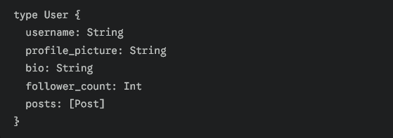
Now, look at how the different frontend teams get exactly what they want without the backend team writing a single line of new code:
- The Mobile App asks for:
GraphQL
- The Web App asks for:
GraphQL
{ user(id: 1) { username profile_picture bio follower_count posts { title } } }
- The Smart Watch asks for:
GraphQL
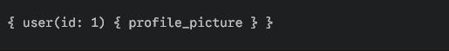
The GraphQL engine on the server automatically parses these incoming requests and strips away the unrequested fields on the fly.
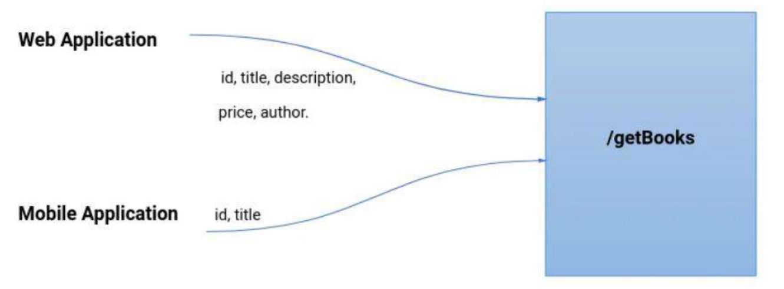
Summary: The Real Difference
Concept | The REST Approach | The GraphQL Approach
Flexibility | Static. The server pre-packages the box of data. If you want a different box, the backend developer must build a new endpoint. | Dynamic. The server provides a grocery store of data. The frontend takes a shopping list and grabs exactly what it needs.
Control | The Server dictates the response structure. | The Client dictates the response structure.
Code Maintenance | Code grows complex over time with custom filters, query params (?fields=name,email), or cloned endpoints. | Code remains clean because a single graph structure handles all use cases natively.


2. GraphQL vs. REST: Key Differences
Feature | REST API | GraphQL API
Routing | Multiple URLs (/users, /posts, /likes) | One Single URL (/graphql)
Data Control | The Server decides what data you get. | The Client decides what data it wants.
Efficiency | Suffer from Over-fetching (too much data) and Under-fetching (requires multiple requests). | Perfect Fetching: Exactly what you need in a single round-trip.
Versioning | Requires versioning in the URL (/api/v1/, /api/v2/). | No Versioning. Just add new fields to the graph; old fields can be safely ignored or deprecated.

3. How GraphQL Works Internally (Under the Hood)
Many people think GraphQL is a database or magic. It is neither. It is simply an orchestration layer written in code.
When a client sends a query to a GraphQL server, the server runs it through a 3-step engine: Parsing Validation Execution.
Let’s trace our Social Media Feed query through the backend engine:

Step 1: Parsing (Building the Tree)
The client sends a raw text string over HTTP POST to /graphql:
GraphQL
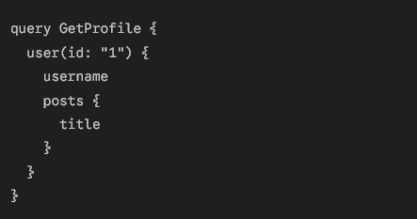
The internal GraphQL engine reads this plain text string and breaks it down into a computer-readable tree structure called an AST (Abstract Syntax Tree).
Step 2: Validation (Checking the Rules)
The engine checks the AST against your Schema (the master blueprint file you wrote on the backend defining what data is allowed).
- It checks: "Does the user type exist?", "Does user actually have a field called username?", "Is id a string?"
- If a hacker tries to ask for a field that doesn't exist (like user.password), the engine stops immediately and throws a validation error before hitting any database.
Step 3: Execution (Running the "Resolvers")
If validation passes, the engine executes the query top-down, layer-by-layer. To do this, it calls Resolvers.
What is a Resolver?
A resolver is a simple function written by a developer that tells a specific field where to get its data. A resolver can fetch data from a SQL database, a MongoDB cluster, a cache, or even an external REST API.
Here is how the engine traverses our query tree internally:
- Root Level (user(id: "1")): The engine executes the user resolver.
  - Code logic: SELECT * FROM users WHERE id = 1;
  - Result: The database returns a User object.
- Next Level (username): The engine looks at the User object and pulls out the username property.
- Nested Level (posts): The engine sees that the client wants posts. It takes the user's ID (1) and fires the posts resolver.
  - Code logic: SELECT * FROM posts WHERE author_id = 1;
  - Result: The database returns an array of posts.
- Leaf Level (title): The engine loops through the posts array and extracts only the title string from each post, discarding everything else (like post content, timestamps, etc.).
Step 4: Stitching and Response
The engine collects all these individual resolved pieces, maps them into a JSON structure that perfectly matches the shape of the original query, and sends it back to the client:
JSON
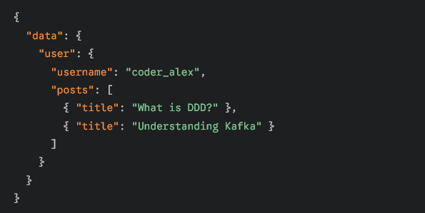
4. Main Uses of GraphQL
Where do companies actually use this?
- Mobile Applications: Because mobile phones run on cellular data and batteries, saving bandwidth via perfect fetching makes apps significantly faster and smoother.
- The API Gateway Layer (BFF - Backend for Frontend): If a company has 50 different microservices (Billing, Shipping, Auth, Inventory), they can put one GraphQL server in front of all of them. The frontend team talks to the single GraphQL endpoint, and the GraphQL resolvers act as traffic cops routing requests to the correct internal microservices underneath.

- Multi-Platform Ecosystems: If you have a Smart Watch app, a Mobile app, and a Desktop Web app all using the same backend, you don't need different endpoints. Each device just writes its own custom GraphQL query to pull the exact layout density it needs.

GraphQL Subscriptions are a feature used to push data from a server to a client automatically and instantly whenever a specific event happens.
Unlike standard queries where the client has to keep asking ("Do you have new data now? How about now?"), a subscription sets up a permanent pipe between the client and the server. The client sits back, and the server pushes the updates the millisecond they occur.

The Analogy: Ordering Pizza 🍕
- Standard Query (Polling) is like calling the pizza shop every 2 minutes: "Is my pizza ready? No? Okay, I'll call back." 2 minutes later: "Is it ready now?" It wastes your time and annoys the pizza shop.
- GraphQL Subscription is like a live GPS tracker on your phone: You place the order, a live map opens, and you watch the delivery driver move down your street in real time. You don't have to refresh anything; the screen updates automatically.


How It Works Under the Hood: WebSockets
Standard APIs use HTTP, which is a "request-and-response" system. The connection closes as soon as the data is sent.
GraphQL Subscriptions use WebSockets. A WebSocket opens an ongoing, two-way highway between the phone/browser and the server that stays open indefinitely.

A Running Example: A Live Sports Score App 🏏⚽
Imagine you are building an app that shows live football scores. You want the score to update instantly on the user's screen without them having to pull-to-refresh.

1. The Schema (The Setup)
On the backend, the developer defines a special Subscription type in the GraphQL schema:
GraphQL
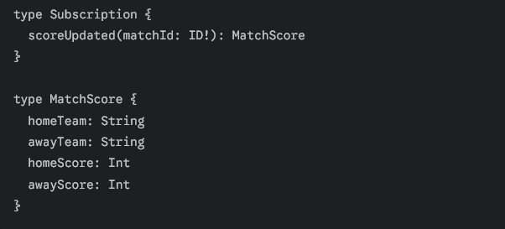
2. The Client Subscribes
When a user opens the match page for Game #99, the frontend application sends a Subscription Request over the WebSocket connection:
GraphQL
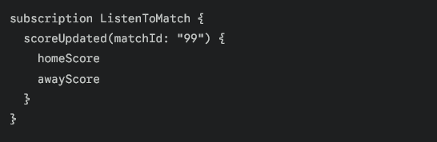
The server acknowledges this and keeps the connection open, listening specifically for updates on match "99".
3. The Real-Time Trigger
Ten minutes later, Team A scores a goal.
- A referee or data system updates the database via a GraphQL Mutation (updateScore).
- The server processes the mutation and immediately fires an event to the subscription handler.
- The server pushes this specific JSON payload down the open WebSocket pipeline directly to our user's phone:
JSON
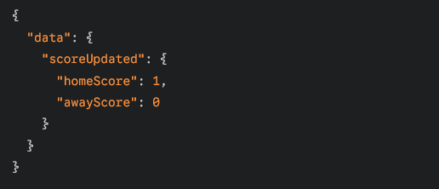
The phone receives this instantly, and the UI dynamically ticks up from 0-0 to 1-0 without the user blinking.
When should you use Subscriptions?
While they are powerful, you shouldn't use them for everything because keeping thousands of WebSocket connections open consumes a lot of server memory.

Best Use Cases:
- Chat Applications: Seeing a message appear the moment your friend types it.
- Live Feeds: Stock market tickers, live sports scores, or crypto price charts.
- Collaborative Tools: Seeing where another user’s cursor is pointing in a shared Google Doc or Figma file.
- Progress Bars: Watching a massive file upload or video rendering process count up from 1% to 100% in real time.

Yes, a mutation happens on the database/server, and because that pipeline (WebSocket) is wide open, the server instantly fires the new data down to any client that has an active subscription open. The client doesn't pull, refresh, or call anything—they just sit back and get notified automatically.

1. Where do we use Subscriptions? (Compared to a REST Point of View)
GraphQL Query is like a REST GET, and
a Mutation is like a REST POST/PUT/DELETE. So where does a Subscription fit in the REST world?
In standard REST, there is no direct equivalent because REST is strictly built on a "Request-And-Response" rule (the client must ask first). However, if a REST developer wants to achieve the exact same real-time behavior, they have to use entirely different workarounds:
Real-Time Goal | The REST Workaround | The GraphQL Way
How it looks | Polling: The frontend app runs a hidden loop that sends a REST GET request every 3 seconds to check for updates. | Subscription: The client sends one request to open a pipeline, then waits.
Network Traffic | Heavy & Wasteful: 99% of those repeating REST calls return "No new data," wasting battery and bandwidth. | Light & Efficient: Zero network traffic passes through the pipe until an actual update occurs.

2. Is the word "Subscribe" on YouTube the same concept?
Conceptually, yes. Technically, no.
- The Concept is identical: When you click "Subscribe" on a YouTube channel, you are telling YouTube, "Hey, I am interested in this creator. Don't make me manually check their page every day. Just push a notification to my phone the exact millisecond they upload a new video."
- The Technical difference: GraphQL Subscriptions are for active code running right now on an open screen (like keeping a live chat box updated while you are looking at it). YouTube subscriptions handle asynchronous background notifications even when your app or phone screen is completely turned off.

3. What is a WebSocket?
A WebSocket is a communication protocol (a set of rules) that allows a web browser or mobile app to open a permanent, two-way digital pipeline with a server.

The Difference Between HTTP and WebSockets:
- HTTP (Standard Web/REST) is like a Walkie-Talkie:
  - * The client presses the button: "Give me the user data, over."
  - * The server responds: "Here is the data, over and out."
  - * The connection is now completely dead. If the server wants to tell the client something new 5 minutes later, it cannot—it has to wait for the client to call again.
- WebSocket is like a Phone Call: * The client calls the server, they establish a connection, and neither side hangs up.
  - The line stays wide open. The client can talk to the server, or the server can randomly scream, "Hey! Someone just liked your photo!" without the client asking.

Summary: How they all tie together
WebSocket is the underlying copper pipe (the infrastructure).
GraphQL Subscription is the structured language traveling inside that pipe to make sure the server sends the exact fields the frontend requested.

When to use GraphQL?
Some clients or services need only certain pieces of data. GraphQL lets them ask for exactly what they want.
Instead of calling many REST endpoints, GraphQL can fetch all needed data in a single request.
Real-World Example
Imagine a hospital management system with these services:
  - Patient Service: stores patient details.
  - Appointment Service: stores doctor appointments.
  - Lab Service: stores test results.

A doctor’s dashboard needs:
  - Patient name and age
  - Upcoming appointments
  - Latest lab results.
Without GraphQL, the dashboard might make three separate REST calls
With GraphQL:
1. The dashboard sends a single query requesting patient info, appointments, and lab results.
2. GraphQL collects data from all three services and combines it into one response.
What this really means is GraphQL itself does not store data. It acts like a middle layer. It calls Service A, Service B, and Service C, gets data from each one, then puts everything together and sends one clean response back.
3. The response contains exactly what the dashboard needs in one call.

Why use GraphQL instead of REST?
It gives us a single endpoint, we do not need to create the different APIs for the same data. GraphQL is strongly typed, you can also check or validate the GraphQL query before the execution.
• GraphQL helps to build powerful APIs and clients also know what they exactly want and what different types of operations they can perform.
Example-
• Suppose, we have two applications one is Web Application and the second is Mobile Application, and /getBooks is an API for fetching the data.
• Web Application can send the request for getting the book details by using the field like id, title, description, price, and author, also Mobile application wants the same data but uses only two fields id and title only.
• But we made the normal APIs, so Mobile Application wants only two fields of id and title, but by using normal APIs Mobile Application gets all the data like id, title, description, price, and author when the Mobile application hits the same endpoint /getBooks.
• Even though we use different data we made the different REST APIs for Web Application and also for Mobile Application, so this is a very costly and inefficient way. This problem is solved by GraphQL. By using GraphQL the data is passed into the form of the query by using a single endpoint.
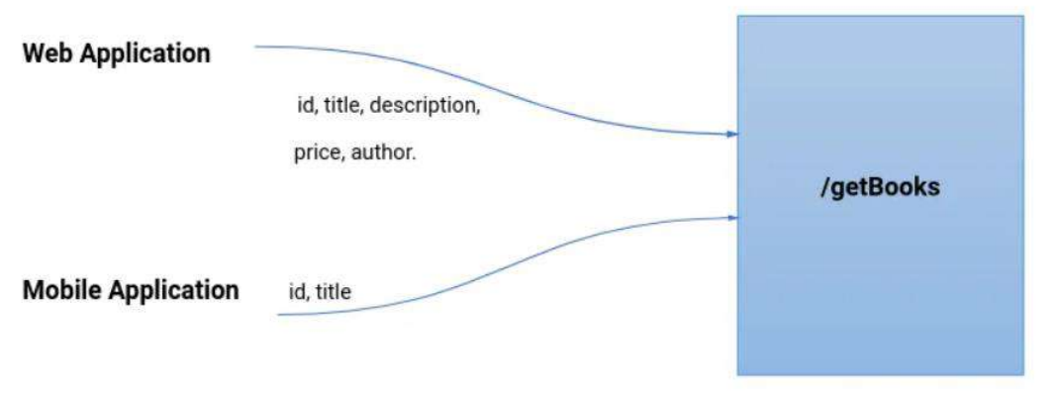
What is dependency used for GraphQL in Spring?
We add the dependency spring-boot-starter-graphql in our project to enable GraphQL support. This brings everything needed to handle GraphQL requests, queries, schema files and mapping annotations. Once added, we can expose GraphQL endpoints and write queries without creating multiple REST controllers or endpoints.
Example:
